Keyboard W camera moves toward

Keyboard S camera moves backward

Keyboard A camera moves leftward

Keyboard D camera moves rightward

Keyboard space camera moves down

Keyboard shift camera moves up

Keyboard L switch camera moving mode between auto moving and control moving

Keyboard M switch Multiple scenes on screen to singal scene

Mouse camera looks around

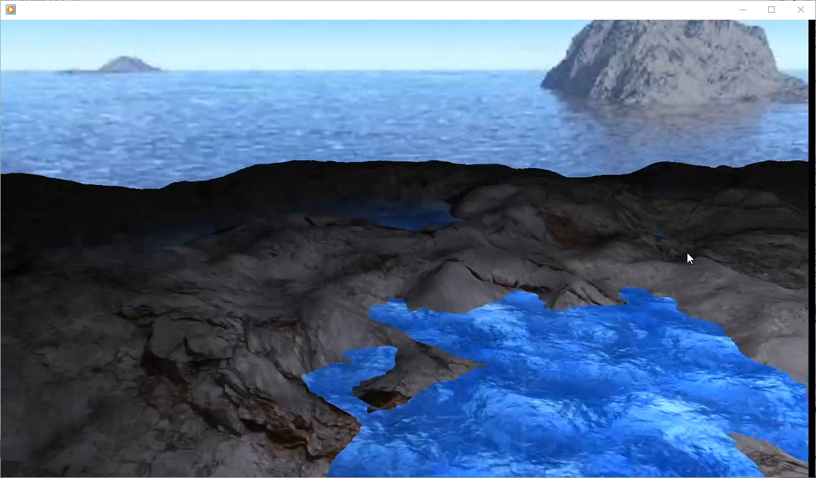

Initial picture

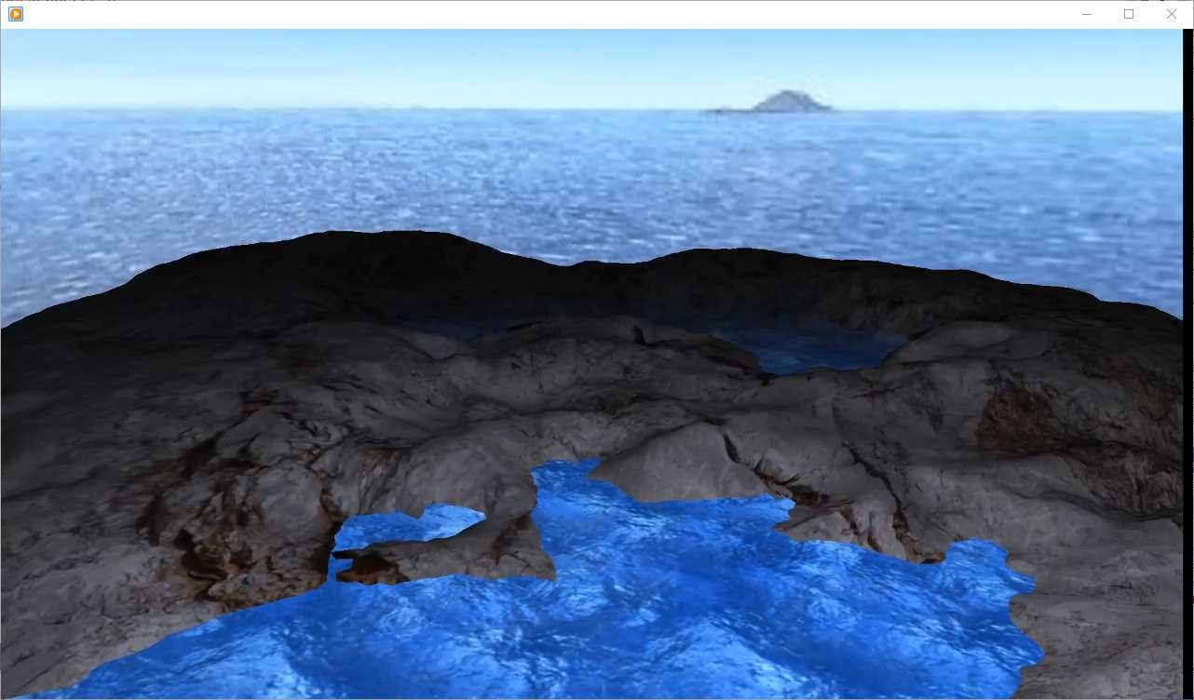

Water move up and down

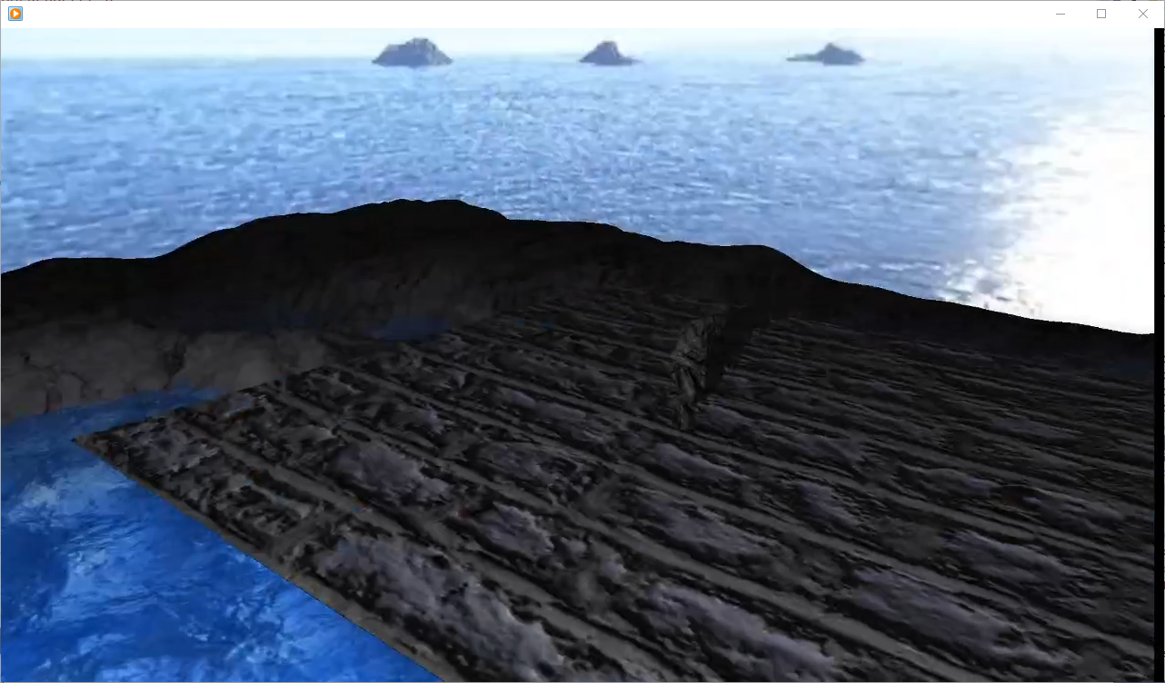

The monster

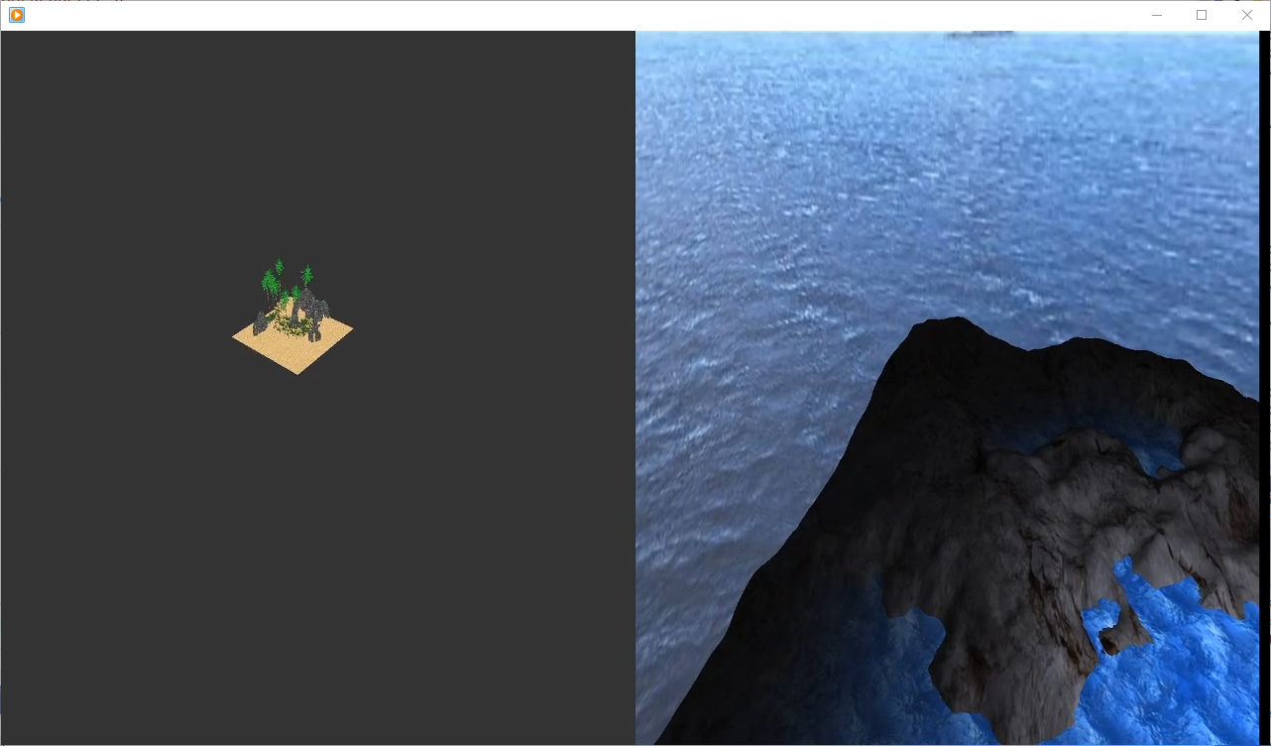

Multiple scenes